This is a screenshot with the Customers database. The primary key is CustomerID
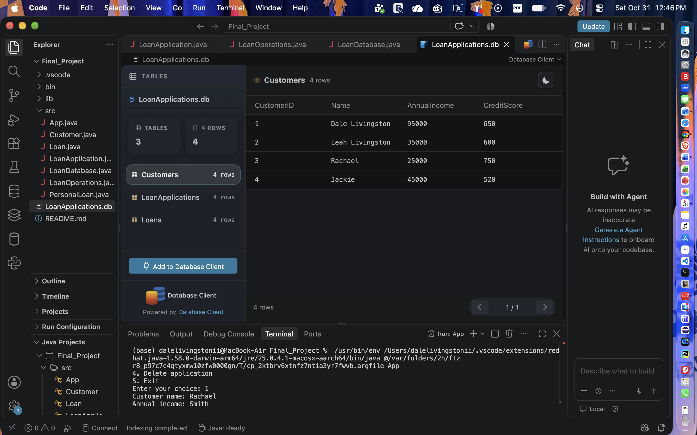
This picture is a screenshot of LoanApplications. The Primary key is ApplicationID.
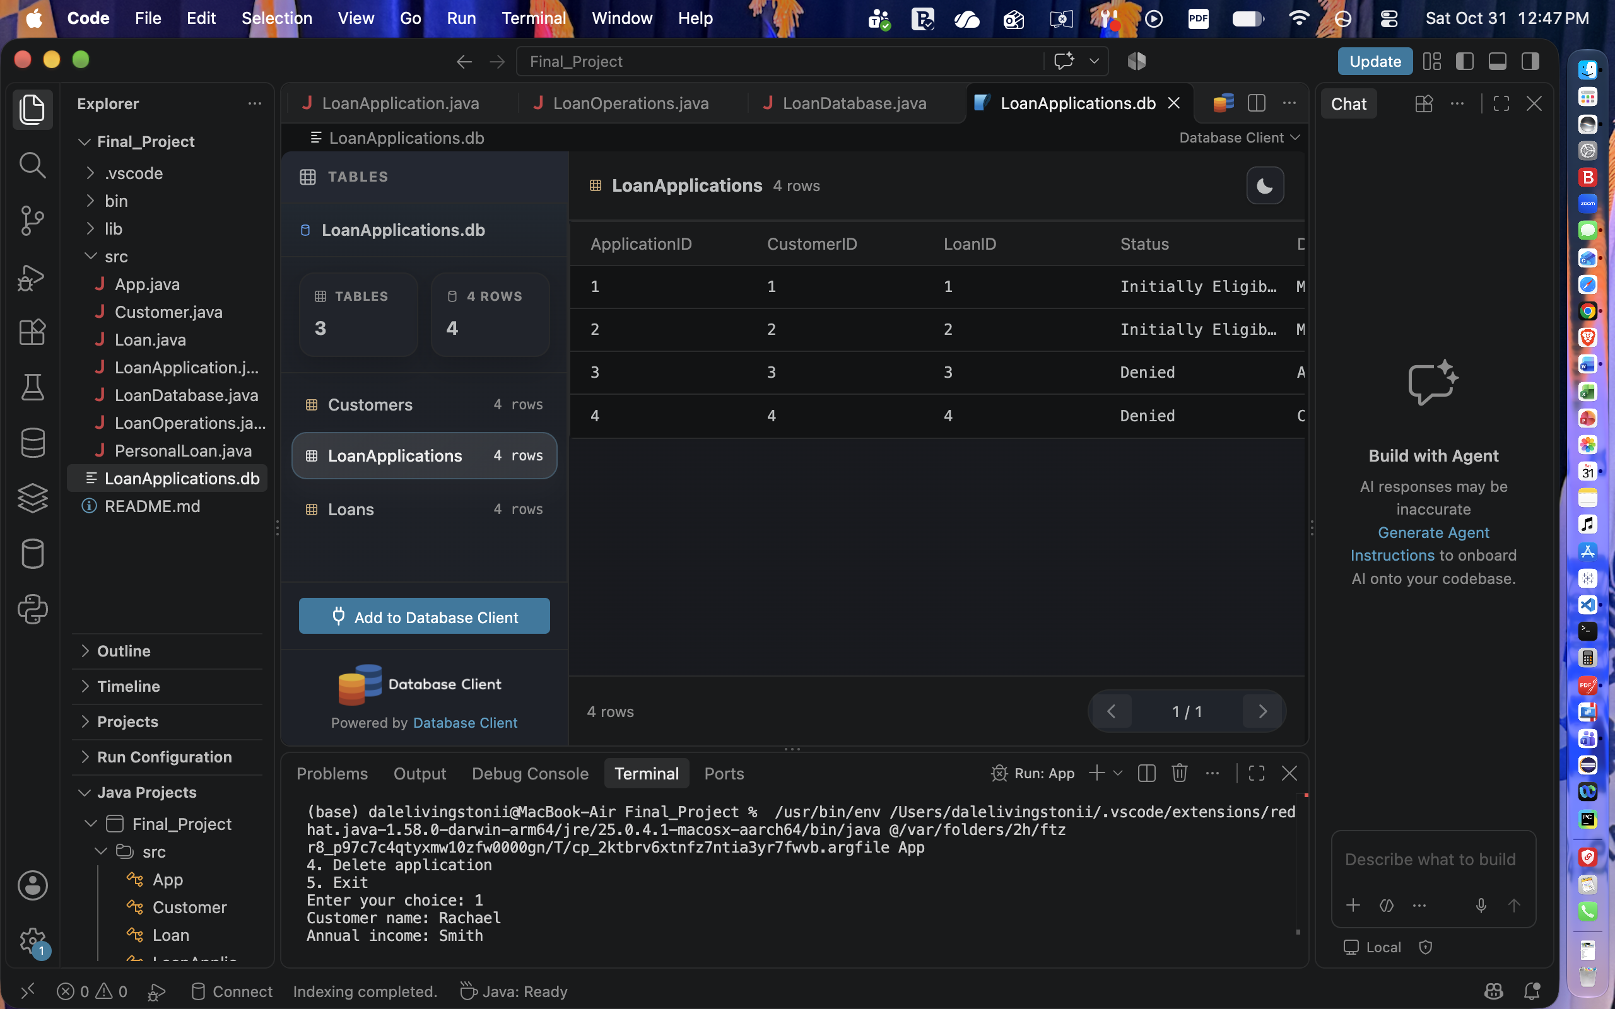
This is a screenshot of the Loans database. The Primary key is LoanID.
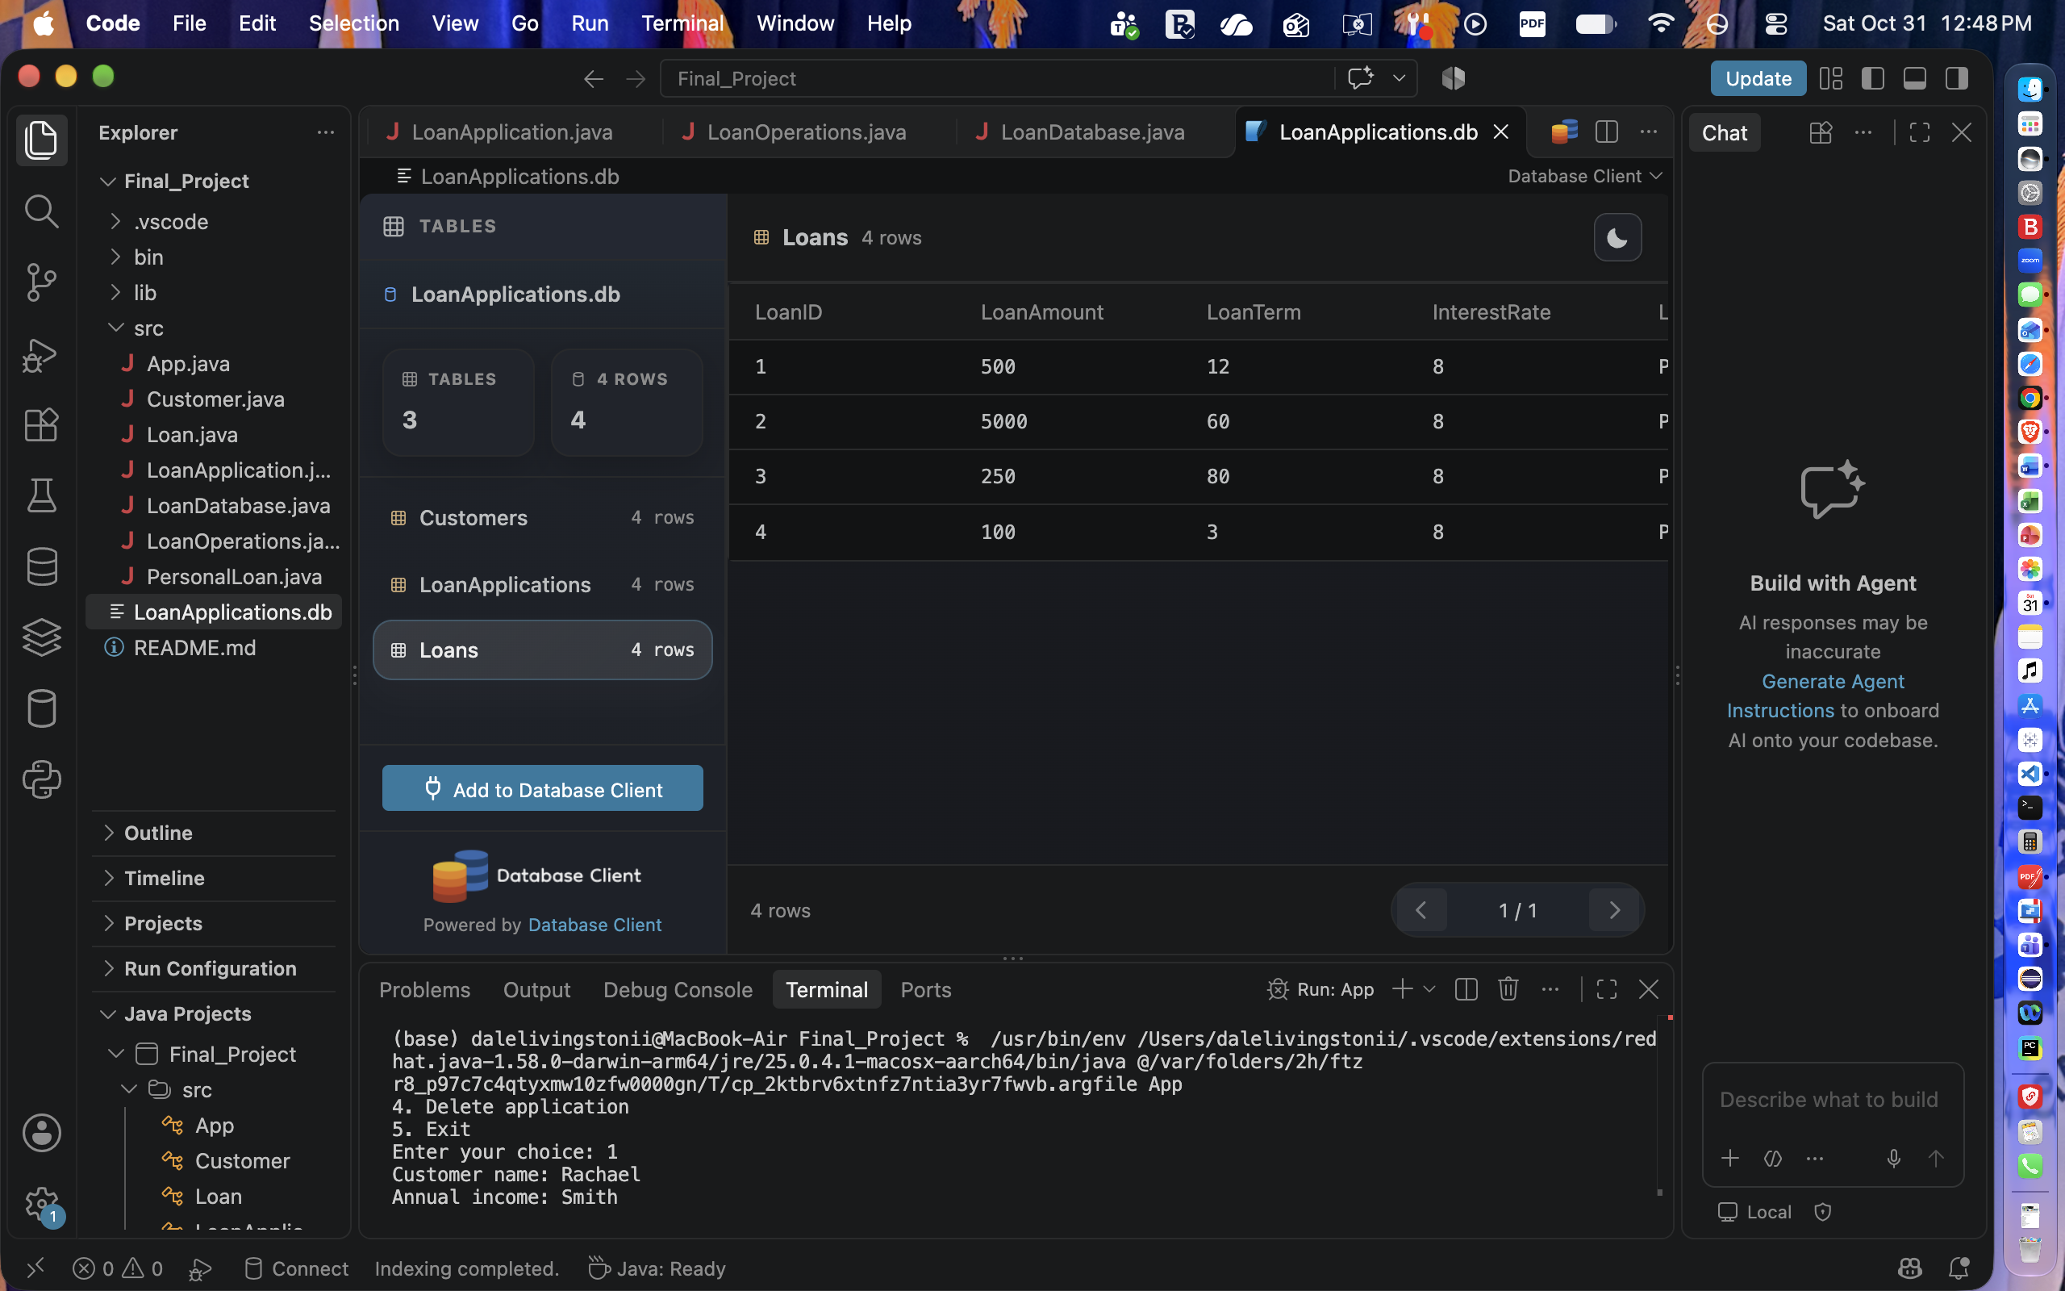
Here is a screenshot for the code for my Customers database.
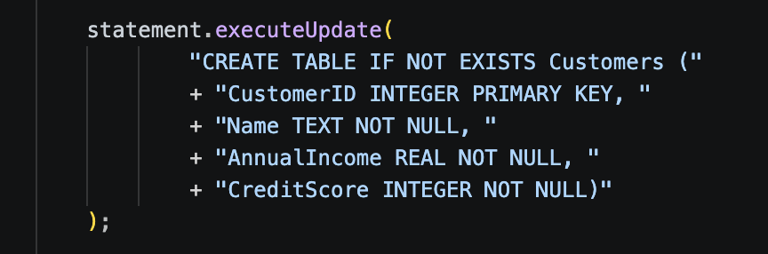
Here is a screenshot for the code for my LoanApplication database.
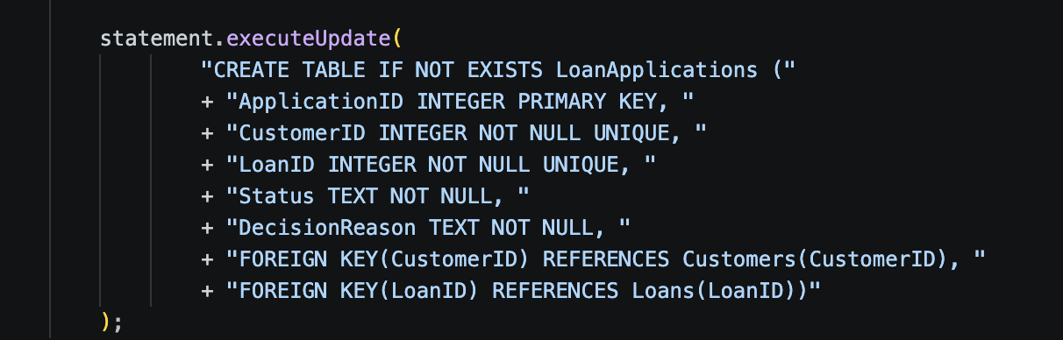
Here is the screenshot for code for my Loans database.
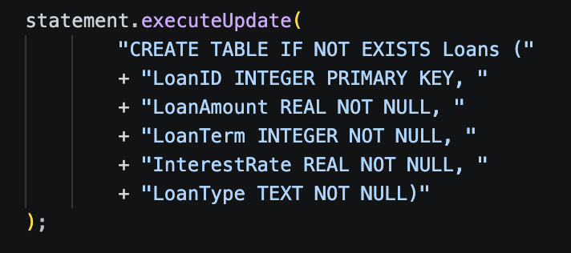..
Here is the output of my application in CLI.
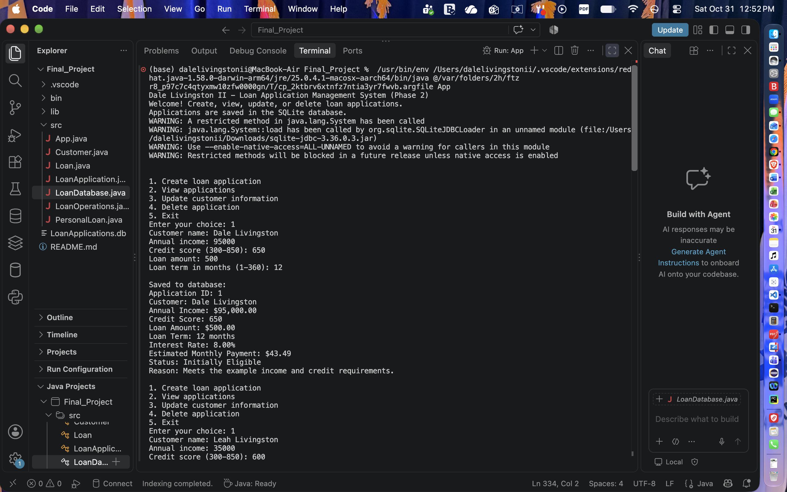
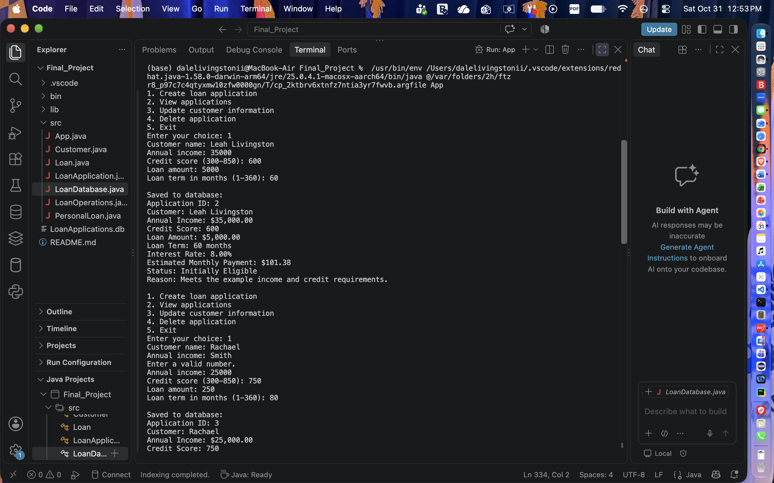
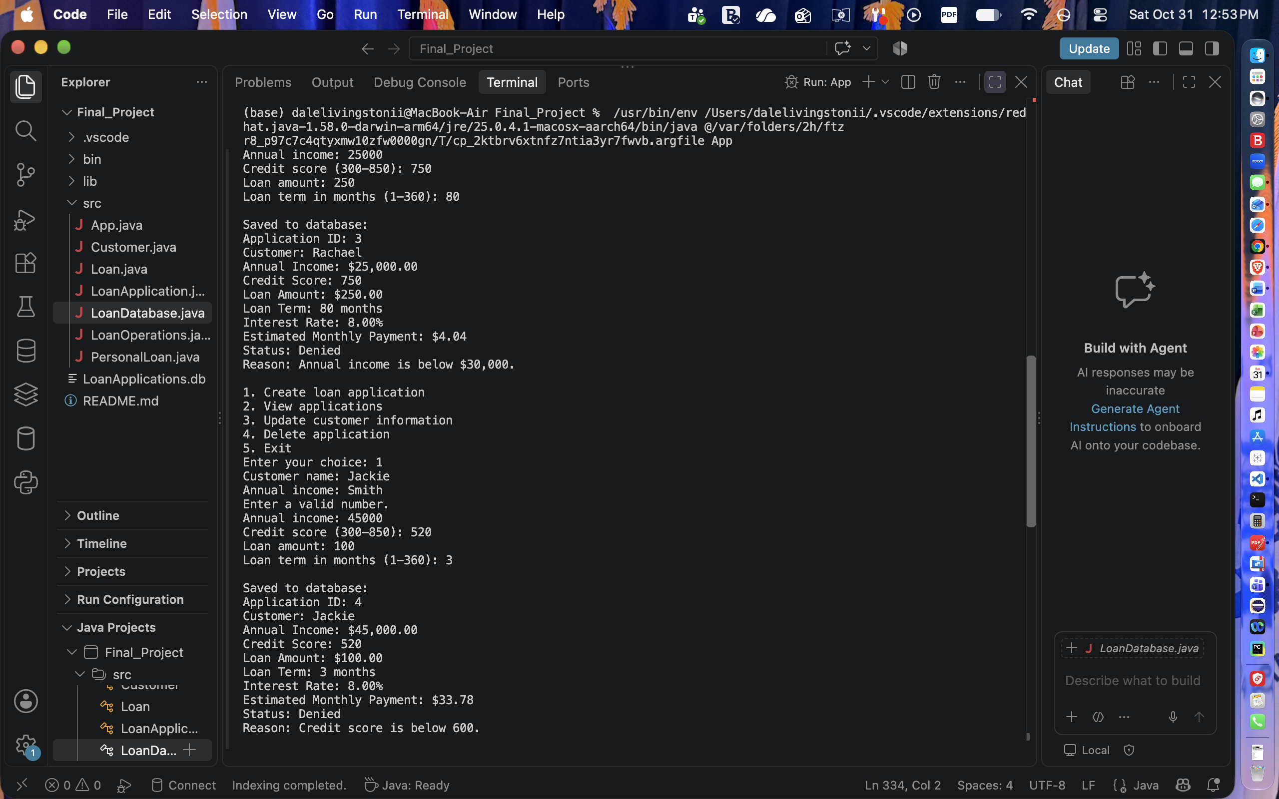
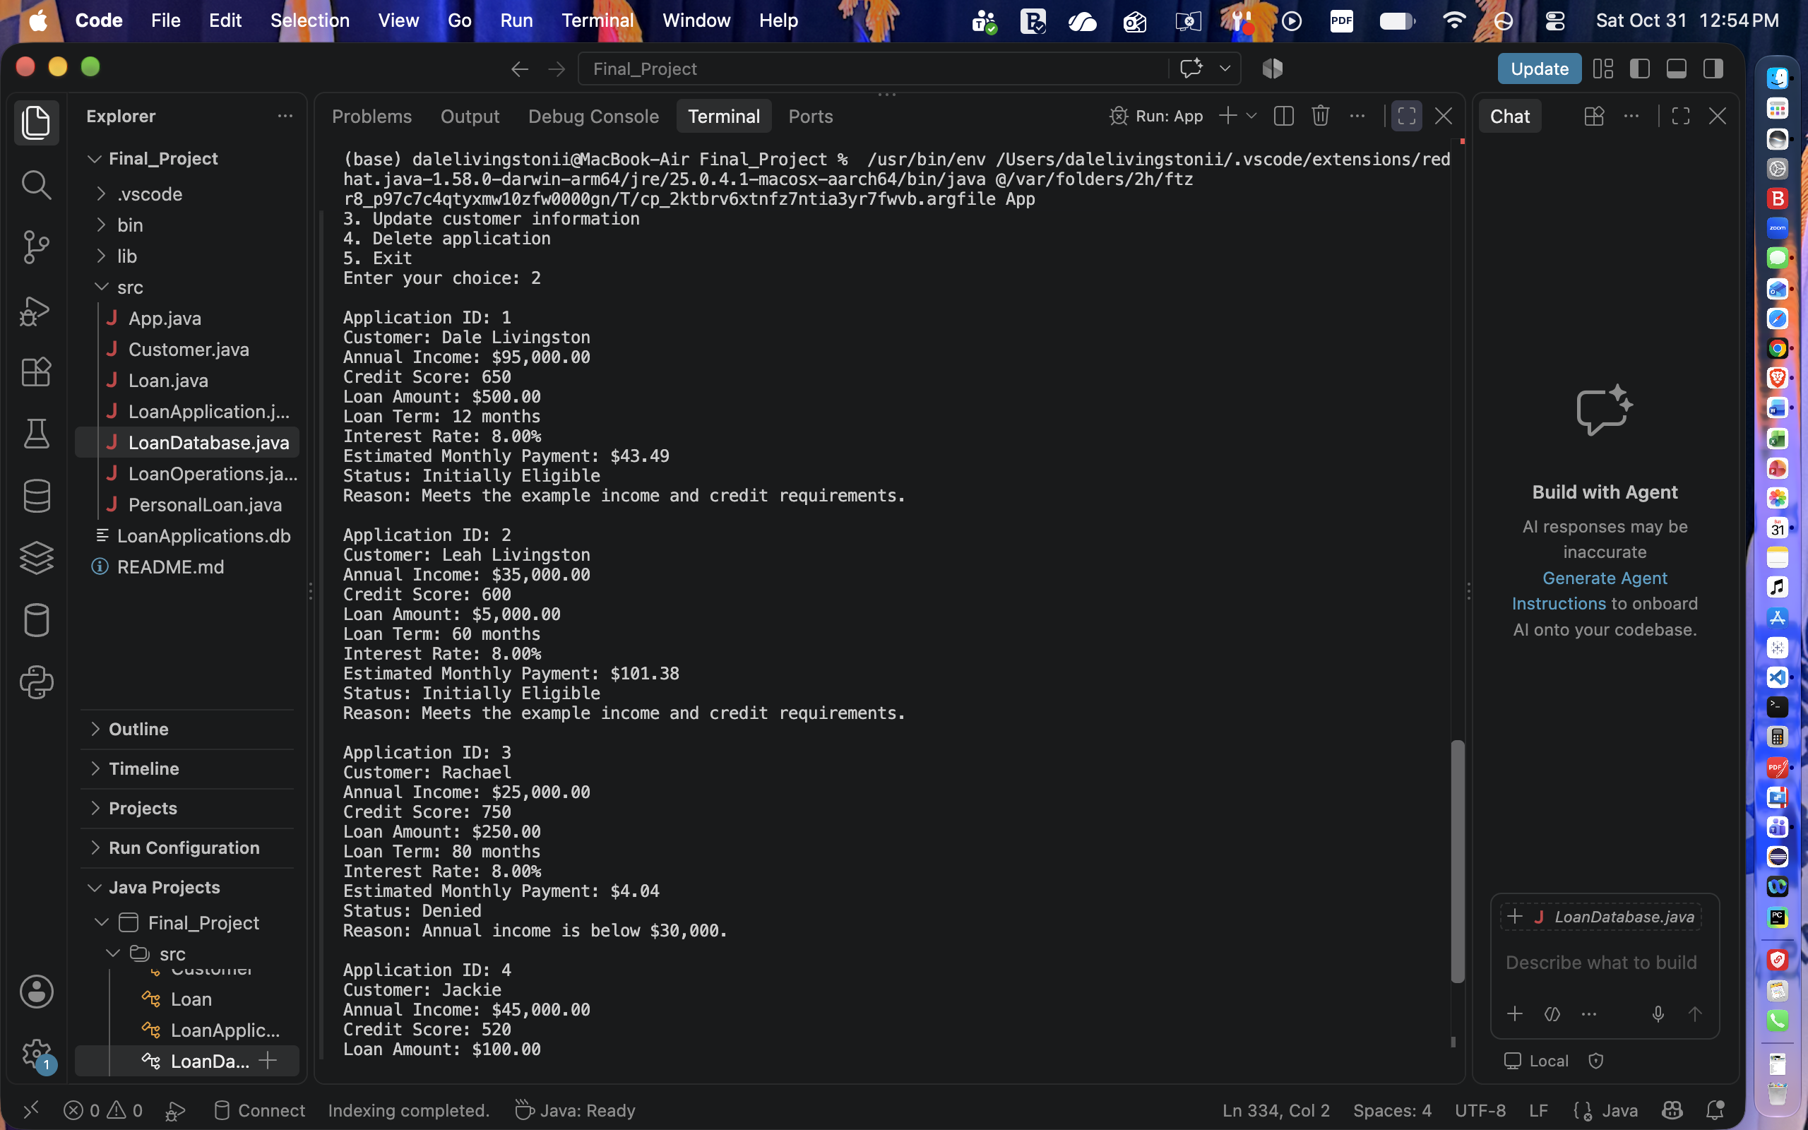
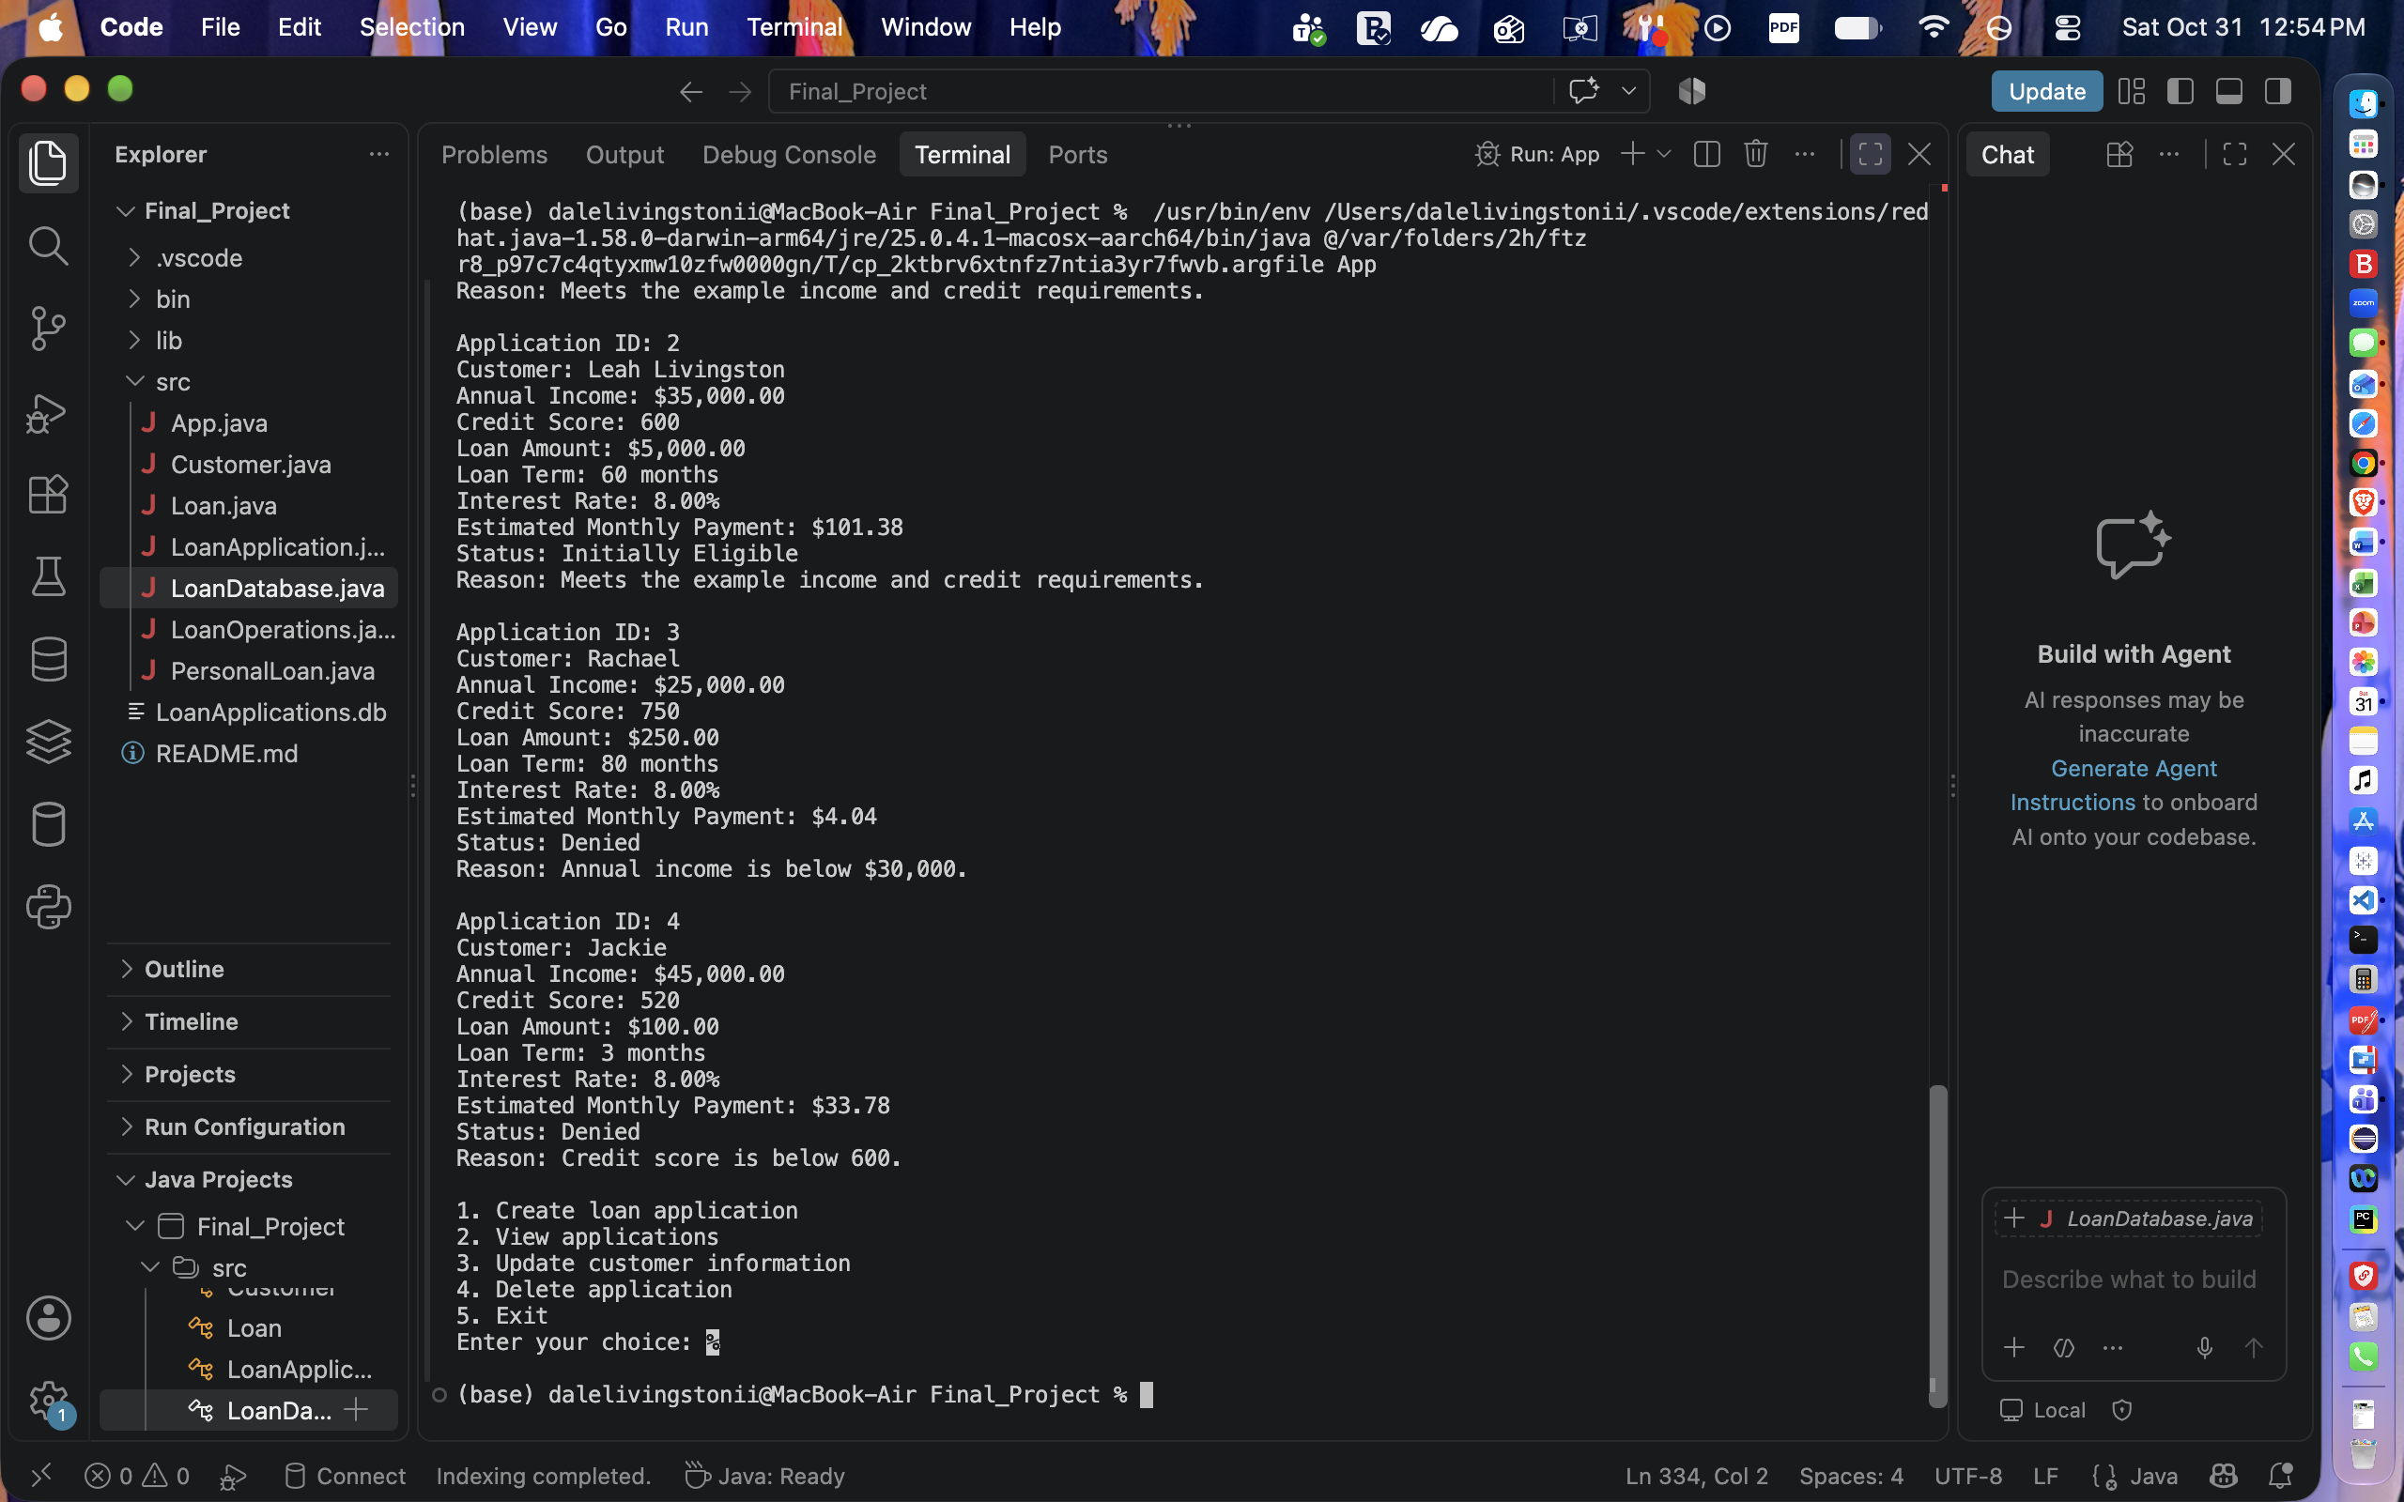
Here is my screenshot of me running the application again after I stop it to make sure the database is working correctly.


